Примеры инфографиков.

Образование:

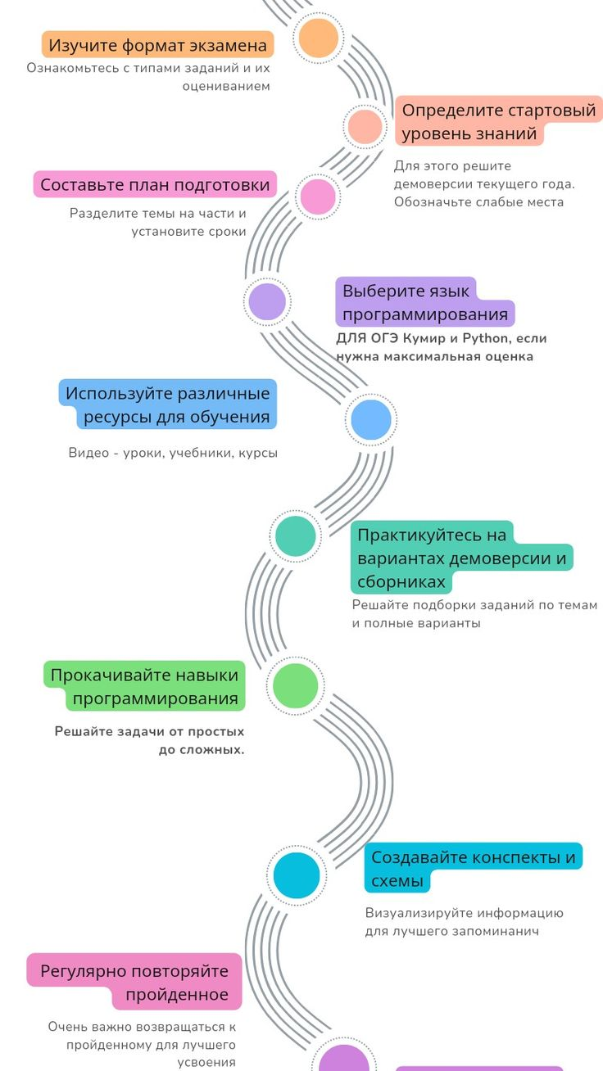

[12 шагов подготовки к экзамену](https://ru.pinterest.com/pin/959829739333361558/)



[Education Success Concept](https://ru.freepik.com/premium-vector/education-success-concept-featuring-fountain-pen-presented-with-four-options-infographic-concept_234344629.htm#fromView=keyword&page=1&position=21&uuid=5ebf0f66-3db4-4db1-9d52-42021a8b8fd3&query=%D0%98%D0%BD%D1%84%D0%BE%D0%B3%D1%80%D0%B0%D1%84%D0%B8%D0%BA%D0%B0+%D0%9E%D0%B1%D1%80%D0%B0%D0%B7%D0%BE%D0%B2%D0%B0%D0%BD%D0%B8%D0%B5)

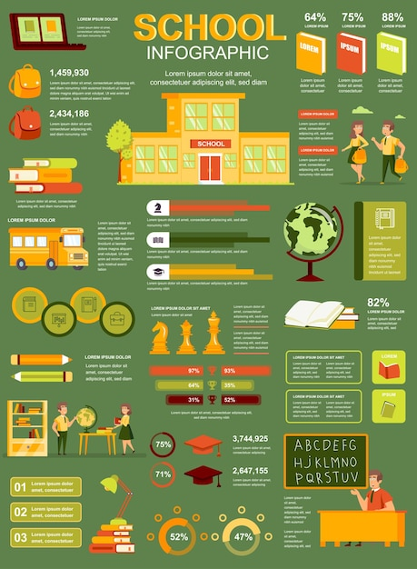

[School](https://ru.freepik.com/premium-vector/school-poster-with-infographic-elements-template-flat-style_13971167.htm#fromView=keyword&page=1&position=42&uuid=5ebf0f66-3db4-4db1-9d52-42021a8b8fd3&query=%D0%98%D0%BD%D1%84%D0%BE%D0%B3%D1%80%D0%B0%D1%84%D0%B8%D0%BA%D0%B0+%D0%9E%D0%B1%D1%80%D0%B0%D0%B7%D0%BE%D0%B2%D0%B0%D0%BD%D0%B8%D0%B5)

Информатика:

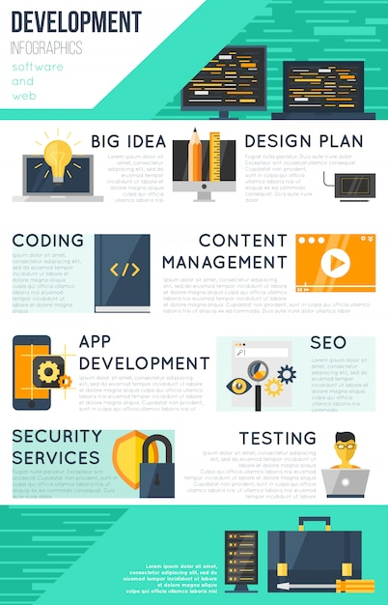

[Какая то про программирование](https://ru.freepik.com/free-vector/program-development-infographic_9386935.htm#fromView=keyword&page=1&position=1&uuid=d7b87367-2236-4cfc-a3da-4e0ebbf7b650&query=%D0%98%D0%BD%D1%84%D0%BE%D0%B3%D1%80%D0%B0%D1%84%D0%B8%D0%BA%D0%B0+%D0%98%D0%BD%D1%84%D0%BE%D1%80%D0%BC%D0%B0%D1%82%D0%B8%D0%BA%D0%B0)

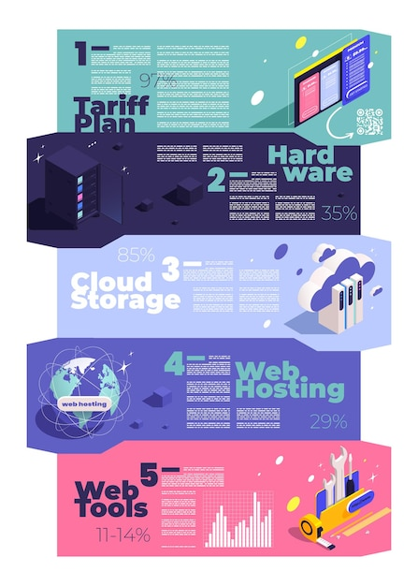

[Про информатику что-то тоже](https://ru.freepik.com/free-vector/web-hosting-icons-isometric-infographics-with-set-horizontal-banners-with-tips-using-internet-tools-vector-illustration_39093881.htm#fromView=keyword&page=1&position=4&uuid=d7b87367-2236-4cfc-a3da-4e0ebbf7b650&query=%D0%98%D0%BD%D1%84%D0%BE%D0%B3%D1%80%D0%B0%D1%84%D0%B8%D0%BA%D0%B0+%D0%98%D0%BD%D1%84%D0%BE%D1%80%D0%BC%D0%B0%D1%82%D0%B8%D0%BA%D0%B0)

Как шаблон буду использовать School Infographics.